SQL> set serveroutput on;

SQL> declare

2 f number:= 1;

3 n number:= &n;

4 begin

5 while n>0

6 loop

7 f:=n*f;

8 n:=n-1;

9 end loop;

10 dbms_output.put_line('factorial is '||f);

11 end;

12 /

Enter value for n: 5

old 3: n number:= &n;

new 3: n number:= 5;

factorial is 120

PL/SQL procedure successfully completed.

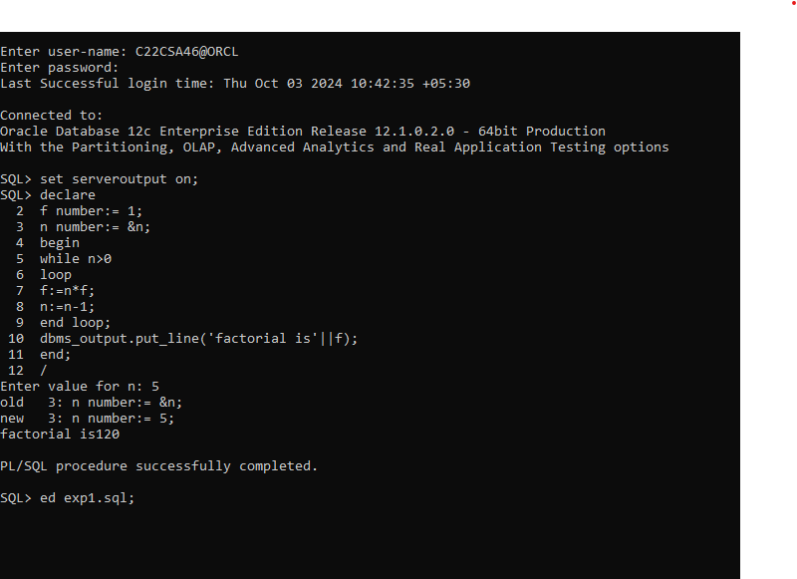

declare

a number:=&n;

b number:=&n;

c number:=&n;

begin

if a>b and a>c then

dbms_output.put_line(a||' is greater than '||b||' and '||c);

elsif b>a and b>c then

dbms_output.put_line(b||' is greater than '||a||' and '||c);

else

dbms_output.put_line(c||' is greater than '||a||' and '||b);

end if;

end;

